Week 14 Blog Assignment DB Schema

Monday, December 08, 2014

2:39 PM

|  |
| --- |
| TAGS |
| Tag |
| TagID |

|  |  |  |  |  |  |  |
| --- | --- | --- | --- | --- | --- | --- |
| |  | | --- | | POSTS | | Post | | PostID | | Title | | Contents | | UserID | |

|  |
| --- |
| COMMENTS |
| TagID |
| PostID |
| UserID |

C:\3359DA25\313AA5BB-9F75-423B-9884-889FADC84250_files\image001.pngC:\3359DA25\313AA5BB-9F75-423B-9884-889FADC84250_files\image002.pngC:\3359DA25\313AA5BB-9F75-423B-9884-889FADC84250_files\image003.png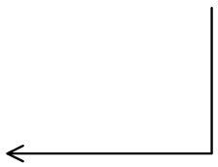

|  |
| --- |
| USERS |
| UserID |
| User |